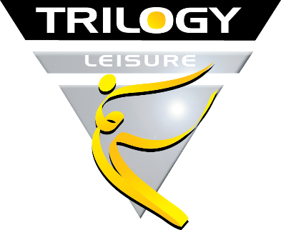

Trilogy Mission
‘Inspiring Active Lifestyles’

Job Description

Job Title: Assistant Sports Coach

Salary: 25 hours – National minimum Wage

Responsible To: Physical Activity Development Officer

Trilogy Culture (Behaviours & Values)

- One Trilogy Team - Working together, respect, open & honest, positive communication
- Encourage Creativity – Support innovation, try new ideas, adopt change
- Be Constructive – Adopt a positive, can-do anything is possible mindset
- Deliver Excellence – Provide the Customer experience you want to receive
- Promote Wellbeing – Self-care, support others, be active, work/life balance
- Embrace Diversity – Champion Equality, Diversity & Inclusion

Trilogy Team Purpose

The purpose of every team member is to work together in a positive, creative fashion as one team to deliver the core values and company strategy. To adopt the behaviours and company culture to promote, encourage and achieve excellence as a Wellbeing organisation to improve the lives of people in our Community.

Organisational Duties & Responsibilities

- Act in accordance with, and positively promote, Trilogy policy and procedures
- Work with the team to deliver the best possible customer experience
- Adopt and adhere to NLT Safeguarding Policy, Procedures and Practices
- Adopt all Health & Safety and all legal compliance in all areas of the business
- Influence, teach and support your colleagues to achieve excellence
- Be accountable for knowing all company process, policy and relevant information
- Communicate, feedback and promote the company values
- Work with the team to deliver the aims and objectives within the company strategy

Individual Duties & Responsibilities

You will be responsible for providing high quality sports coaching for children aged 2-13 years across our Leisure Centres and in various community settings. You will form part of a highly motivated and dynamic sports team that delivers a wide range of children’s activities, including the delivery of an exciting children’s summer programme. You will ensure that children are cared for in a fun and safe environment and be able to build strong relationships with both children and parents (where appropriate).

- To provide and assist on a variety of children’s sports coaching sessions
- To ensure staff and children’s safety and behaviour is always maintained
- To understand and comply with the Northampton Leisure Trust’s Safeguarding Policy
- To ensure implementation of all Health & Safety procedures including the reporting of all accidents and incidents.
- To attend team meetings as required
- Undertake any other duties commensurate with the post’s level of responsibility

Job Demands
- Travel and work from any associated Trilogy facility
- Work the necessary flexible hours to meet the needs of the business (as required)
- Manage (or help manage) conflict and resolve problems within the team
- Be accessible to the whole team for support (as required)

Essential Attributes Required to Work for Trilogy

- Possess the culture, values and behaviours of the company
- Knowledge and experience in relation to the post
- Ability to learn, develop and accept challenge
- Constructive, open minded and a positive communicator
- A team player who want’s others to succeed
- A flexible problem solver
- Be a competent swimmer
- Able to reach a depth test of 3m (training will be given to reach this depth)

Equality, Diversity & Inclusion

Diversity drives innovation and we are committed to promoting equality, embracing diversity and enabling inclusion through positive Wellbeing experiences. Trilogy is committed to educating itself, its workforce and its customers to celebrate Equality, Diversity and Inclusion.

